This document will guide you step-by-step on how to install, setup and populate a MariaDB database in Windows.
- Download MariaDB Server from https://mariadb.org/download/
  - Choose version 10.6.15
- Run the msi installer
  - Click Next
  - Check the license agreement box and click Next
  - Select the MariaDB Server icon and click Next
    - Leave the location as C:\Program Files\MariaDB 10.6\
  - Enter password as root password. Retype the password in the Confirm box. Check the UTF8 as default server character set box and click Next
  - Use TCP port 3306. Click Next
  - Click Install
  - After installation completes, click Finish
  - Navigate to C:\Program Files\MariaDB 10.6\data and open the my.ini file
  - Change the character-set-server value from utf8 to utf8mb4. This is to ensure the full 4 bytes are used for each character in the database.
- Navigate to C:\Program Files\MariaDB 10.6\bin and run a cmd terminal there
- Type mysql -u root -p in the terminal
- Enter the root password
  - If login was a success, the MariaDB [(none)]> prompt will appear 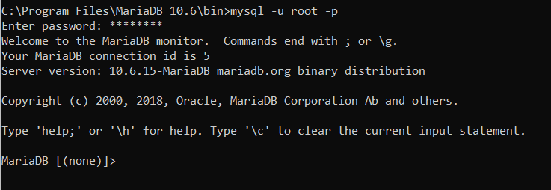
- Enter create database db1; command to create a database named db1
- Enter use db1 to access the database
- Enter the following to create a new table called credentials: 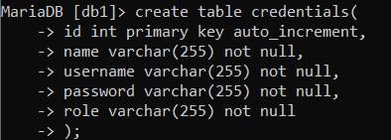
  - This table will contain the name, username, password and role of the employees
- Enter the following to insert two records in the table: 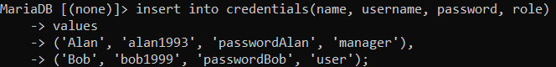
  - Alan is the designated manager and Bob is the designated user.
- Enter the following to check the records in the table: 